0 | 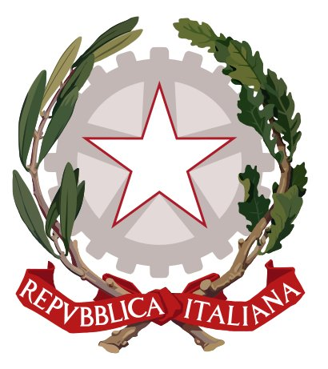 Liceo Classico  “F. Durante”  Frattamaggiore | 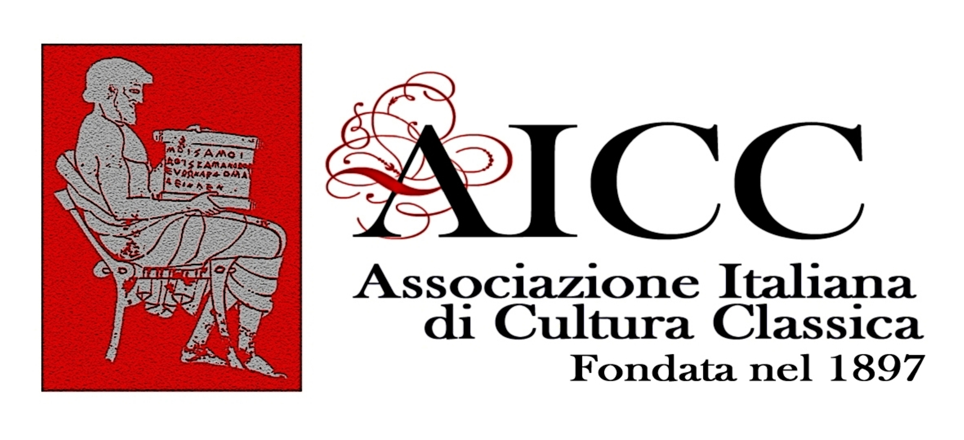

L’ASSOCIAZIONE EX ALUNNI DEL LICEO DURANTE
in collaboration with
il Liceo classico “F.Durante” di Frattamaggiore and
l’Associazione Italiana di Cultura Classica
Delegazione di Frattamaggiore
announces the
ΑΓΩΝ ΠΟΛΙΤΙΚΟΣ
(Agòn politikós)

INTERNATIONAL ANCIENT GREEK COMPETITION

2nd EDITION

Under the patronage of
Lions club “Frattamaggiore”

  Ambasciata di  Grecia |   Univ. degli  Studi di Napoli “Federico II” |   Univ. degli  Studi di Napoli “Parthenope” |   Univ. degli Studi di Napoli “Suor Orsola Benincasa” |  |   Questa iniziativa è contro il sistema della camorra

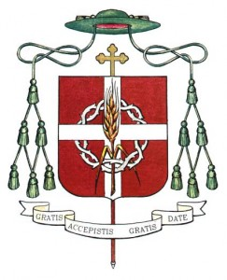  Diocesi di  Aversa |   Comune di Frattamaggiore  (NA) | 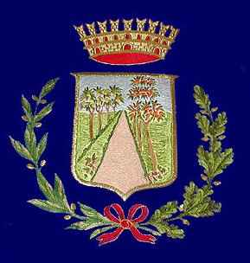  Comune di Grumo Nevano | 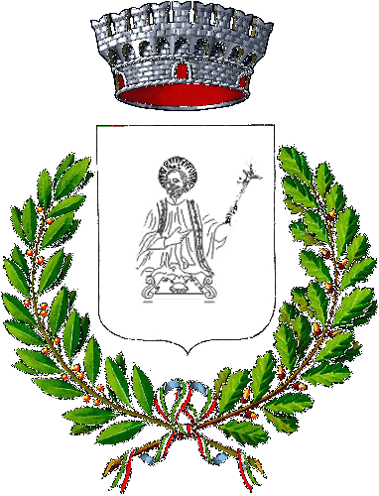  Comune di Sant’Antimo (NA) | 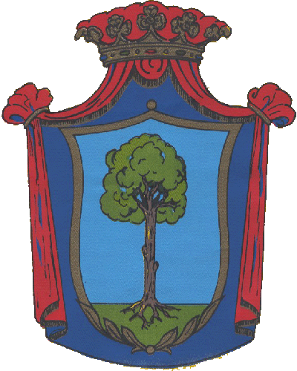  Comune di  Crispano (NA) |   Comune di  Cardito | 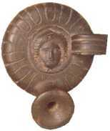Istituto del Studi Atellani


REGULATIONS

Art. 1

L’Associazione ex alunni “F. Durante” in collaboration with Liceo classico “F.Durante” Frattamaggiore and Associazione Italiana di Cultura Classica, delegazione di Frattamaggiore, announces the 2nd edition of the Ancient Greek Competition on the theme of active citizenship, with the purpose of promoting a deeper knowledge of Greek culture from a linguistic and literary point of view.
Admission to the competition is reserved to delegations of Italian students attending the second last and last year at Liceo Classico whose final assessment, by June 2011, is not less than 8/10, and to corresponding schools in Foreign countries whose curriculum includes ancient Greek as a school subject.
As a personal acknowledgement Italian President Giorgio Napolitano has awarded the grand prize winner the Medal of the Presidency of the Republic.
Personal appreciation on and congratulations for the competition have also been expressed by the Minister of Education, University and Research Mrs. Gelmini.
The completion is fully placed among the initiatives aiming at promoting excellence and, in particular, national classical culture Olimpics.
Ministero per i Beni e le Attività culturali, Forum di cultura austriaco, Lions club Frattamaggiore, Greek embassy in Italy, le Università degli studi di Napoli “Federico II”, Parthenope, Suor Orsola Benincasa, Regione Campania, Provincia di Napoli, Diocesi di Aversa, i Comuni di Frattamaggiore, Crispano, Grumo Nevano, S.Antimo, Cardito and Istituto di Studi Atellani have granted their patronage .

Art. 2
The contest consists in the translation from ancient Greek into Italian or in the participants’ mother tongue of an excerpt from Plato’s Politeia, followed by a comment focusing on the linguistic, historical and cultural aspects of the chosen passage .

Art. 3

The competition will take place at Liceo classico “F.Durante – Frattamaggiore on April 20th 2012 at 8:30
It will last 6 hours.
Students are allowed to use only the Greek dictionary.
The usual procedure used for public competitions will be adopted.

Art. 4

Candidates from Licei(no more than two for each Institution) must fill in the application form and hand it over to their school Headmaster .
In the event of more than two applications Headmasters can select candidates to their unquestionable decision.
Applications forms, duly signed by the Headmaster of the applying school must be sent via email(info@associazioneexalunnideldurante.it, or posted to the Associazione ex alunni Liceo Durante di Frattamaggiore (Via Matteotti, 132 – Cap. 80027) by and not later than 15th February 2012. Applications sent after this date will be accepted only if not exceeding the fixed number.
Each group of participants will have to pay € 50,00 as registration fee to the c.c.p. nº 7426010 beneficiary :Associazione ex alunni Liceo Durante, via Matteotti, 132 Frattamaggiore.
The receipt of payment must be attached to the application form.

Art. 5
Participants under 18 must be accompanied either by a teacher of the applying school or by their parents.

Art. 6
Food and accomodation for two students and their teacher from the first ten Licei not located in Campania, from ten different cities which will apply for the competition will be provided by Associazione ex alunni Liceo Durante .

Art. 7

The competitors are required to show a valid identification.

Art. 8

The Board of Examiners, that will choose the passage from Plato’s works the competitors will translate and comment, will be composed by four teachers of Latin and Greek at Licei , either retired or currently teaching and chaired by a Professor in addition to foreign language lectors. In no case will teachers coming from the applying schools be allowed to become members of the Board of Examiners.

Art. 9

The Board of Examiners , to their unquestionable decision:
- assess the competitors’ works and draw up the list for the prize awarding
- can confer an “Honourable Mention”.

PRIZES

- 1st Prize € 600,00 and medal of the Presidency of the Republic awarded, as a personal acknowledgement, by President Napolitano
- 2nd Prize € 400,00
- 3rd Prize € 300,00
- 4th Prize € 200,00

Further prizes will be offered by public and private institutions.

Art.10
All candidates, at the end of the contest, will be given a “Certificate of Attendance” useful to gain school credits and books offered by “Associazione ex alunni del Liceo Durante.
Art.11
The prize-giving cerimony will take place on Sunday 22th April 2012 –
Additional activities:
Seminars, lectures, and guided tours will also be provided.

CALENDAR OF THE EVENTS
Thursday 19th April 2012
18:00 at Liceo classico “F. Durante”-Frattamaggiore
Prof. Michele Ciocia, Headmaster of Liceo classico “F. Durante”-Frattamaggiore
Dott.ssa Anna Soprano, President of Associazione ex alunni del Liceo Classico Durante
Welcome ceremony to delegations
Friday 20th April 2012
From 8:30 competition for students
In the morning a guided tour of Roman Greek Naples for accompanying teachers
20:00 Music
Saturday 21st April 2012
Guided Tour to Paestum
From 20:00 Gala and concert
Sunday 22nd April 2012
10:00 Announcement of Winners
A DETAILED PROGRAM OF THE EVENTS WILL BE SENT TO PARTICIPATING SCHOOLS BY THE MONTH OF FEBRUARY 2012
President of Associazione ex alunni Headmaster
Liceo classico Durante at Liceo classico “F.Durante”
Dott. Anna Soprano prof. Michele Ciocia

For further details please contact Prof.Teresa Maiello- Associazione ex alunni del Liceo Durante and President of local AICC delegation. mobile 0039-33552003644 or Liceo Durante – tel. 081/8318981- 081/8342704.

Hotel

OLIMPIA HOTEL

Via Marconi, 103
80029 Sant’Antimo ( NA) ITALY
TEL. 0039-0815057213
www.olimpiahotels.it

REGULATIONS, CALENDAR OF PREPARATORY CONFERENCES , FURTHER DETAILS AND APPLICATION FORM ON THE WEBSITE:
www.associazioneexalunnideldurante.it
www.liceofrancescodurante.it.

Application form Agòn politikós
2nd edition — SCHOOL YEAR. 2011/12

Associazione ex alunni Liceo Durante
via G.Matteotti, 132
80027Frattamaggiore -

Full name ….........................................................born............................ ….....................pupils at (type of school and location)…………………………
class form.
APPLIES FOR
the competition Agòn politikós — 2nd edition — which will take place at Liceo classico “F.Durante” Frattamaggiore on Friday 20 th April 2012.
Ai sensi della legge n° 196/2003 autorizza il trattamento dei propri dati per le attività della Scuola inerenti il Concorso.(acceptance privacy rules)

s.y.2010/11 -final mark in Greek min. 8
signature

...................................................................

Participant’s address:................................................................................................................

Name and address of the applying school :

…..........................................................................................................................

Teacher ............................................................................................................

Date............................. Headmaster’s signature................................

